More on Gore
By Howard Hayden, Energy Advocate, Via SEPP, July 2026

“ABCNews interviewed Al Gore on the 20th anniversary of his 2006 Inconvenient Truth Movie. The article begins [1]:

The scientists have been right about climate change all along, says former Vice President Al Gore on the 20th anniversary of the release of "An Inconvenient Truth," the Oscar-winning documentary about Gore's campaign to educate people about climate change.

When asked by ABC News chief meteorologist and chief climate correspondent Ginger Zee whether the film and its predictions on global warming hold up, Gore responded, "Unfortunately, yes."

As noted before, the IPCC’s predictions were all over the map. When you predict everything, you predict nothing. Pick a date. Pick a temperature. They predicted it!

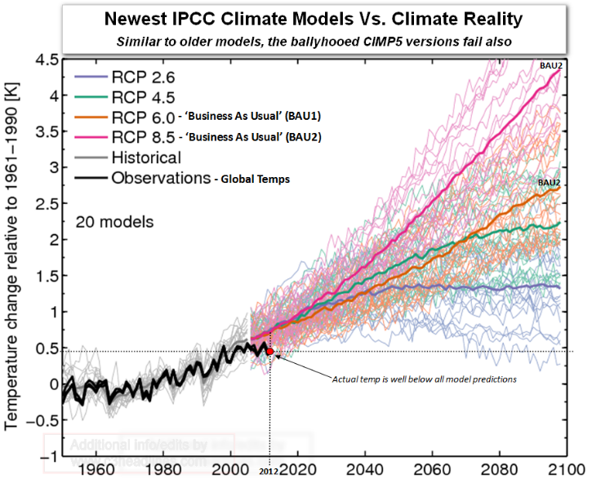

I wish I knew how to give credit for the graph below!
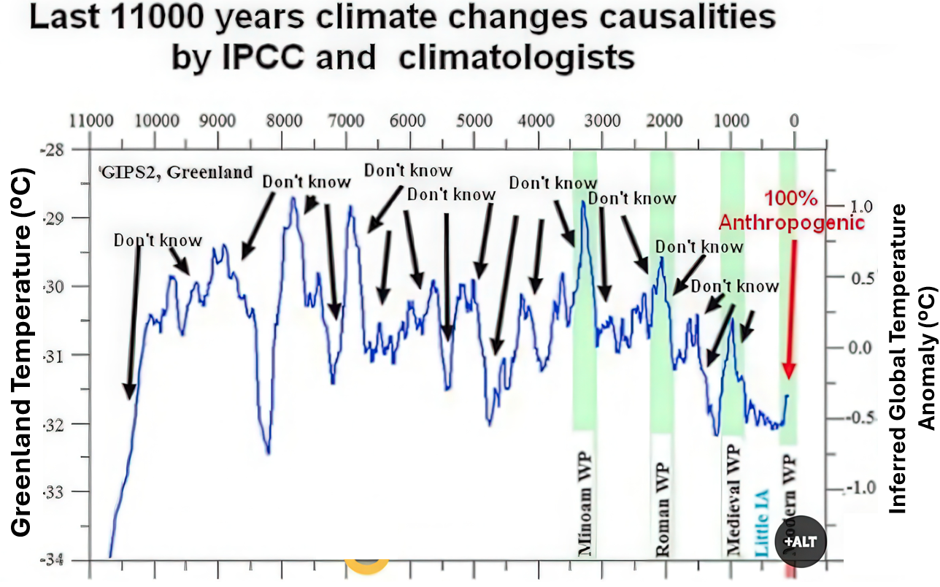

[1] 'Scientists were dead right': Al Gore says on 20th anniversary of 'An Inconvenient Truth,' https://abcnews.com/US/scientists-dead-al-gore-20th-anniversary-inconvenient-truth/story?id=133922490”

To TWTW the graph line of “Last 11000 years climate changes causalities by IPCC and climatologists” is consistent with GRIP2 ice cores taken at Summit Station, Greenland (elevation about 3,216 meters (10,551 feet) above sea level). But as with Hayden, TWTW was unable to discover who inserted the “Don’t know” arrows. Nor does Mr. Gore know what caused the previous increases and declines in temperatures. It was not CO₂, which was roughly constant during the glacial period at 180 to 200 parts per million in volume (ppmv), then gradually rose to about 250 to 280 ppmv prior to the industrial age starting about 1750 with the development of the improved steam engine by James Watt (1769) with a separate condenser.

The above “Don’t know” graph applies to many organizations that are considered scientific but follow the UN Intergovernmental Panel on Climate Change (IPCC). These organizations may use the tools of science but ignore natural variability, thus assuring their own ignorance. See link under Challenging the Orthodoxy.

